**Launch Playbook**

GROWING OUR COMPETITIVE ADVANTAGE WITH GROOPIT

**Table of Contents**

**Introduction**

**Timeline**

**Phase One: Promote**

Week one: Announcement

Week two: Invitation

Week three: Giveaway Teaser

Week four: Leadership Teaser

Week four: Reminder

Promotional Graphics

Promotional Giveaway

**Phase Two: Event**

Speakers

Suggestions

Presentation Slides

**Phase Three: Nurture**

Day after event: Send a thank you

Week five: Ask participants to invite a colleague

Week six: Remind participants about the giveaway

Week seven: Share a tip and trick

Week seven or eight: Ask a leader to acknowledge and celebrate progress

Week eight: Announce the giveaway winner

Ongoing: Weekly Highlights Template

Ongoing: Did you groopit? to build a sharing habit

**Checklist**

**Resources**

**Conclusion**

**Introduction: Launch Playbook**

This playbook designed to help you host the kick-off event, "Growing our Competitive Advantage with Groopit." This playbook will equip you with everything you need to promote and deliver the kick-off event, then nurture ongoing engagement.  
  
**Phase one: Promote.** The promotion phase is designed to create awareness and excitement about the event. During this phase, you want every member of the organization to understand the significance of this initiative and emphasize the value of their participation.   
  
**Phase two: Event.** The one-hour event will lay the foundation for future success. It is designed to empower each employee and ignite the momentum to excel in our competitive landscape.  
  
**Phase three: Nurture.** Following the event, is the nurturing phase, where you recognize and appreciate the ongoing contributions of employees and acknowledge the business outcomes positively impacted by shared competitive intelligence.   
  
Please use this playbook as a starting point and customize it to reflect your company’s vision, goals, and culture. We appreciate this opportunity to set a strong foundation for our collective success and embrace the growth that lies ahead.

**Timeline**

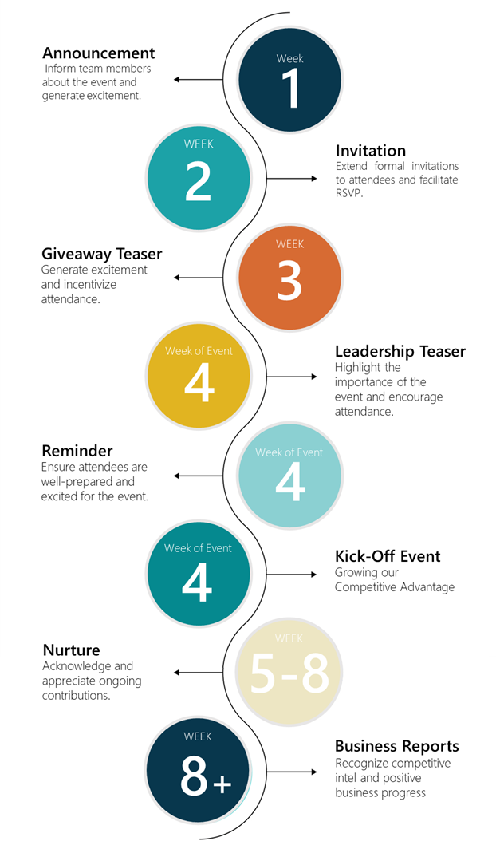The timeline for our kick-off event involves initiating promotion three weeks ahead, intensifying promotion in the week leading up to the event, and then transitioning to the nurture phase post-event.

To help you manage the timeline, we have provided a [customizable task list](https://groopit.co/wp-content/uploads/2023/06/Groopit-Kick-Off-Task-List.xlsx).

# 

# **Phase One: Promote**

This section provides assets to promote the kick-off event and engage attendees. The campaign is crucial to ensuring the success of this important occasion. The recommended event title is, "Growing our Competitive Advantage: {insert your company name here} + Groopit” and will be used through the promotional campaign. There are five elements:

* Announcement | Inform team members about the event and generate excitement.
* Invitation | Extend formal invitations to attendees and facilitate RSVP.
* Giveaway Teaser | Generate excitement and incentivize attendance.
* Leadership Teaser | Highlight the event’s importance and encourage attendance.
* Reminder | Ensure attendees are well-prepared and excited for the event.

This playbook contains customizable draft assets for the kick-off event promotion. These assets, including messages and graphics, are designed to engage potential attendees, generate excitement and communicate the kick-off’s importance. The draft messages are also available in [doc format](https://groopit.co/groopit-launch-communication-templates-2/) for easy copy and paste.

**Quick Tip:** Throughout these assets, you’ll see various emojis. To add them to Outlook messages, press the Windows key + period key. To use the {Company} and [Groopit logos](https://groopit.co/wp-content/uploads/2019/08/groopitfavicon.png) as emojis in Slack, simply add them as custom emojis. [Instructions are available here](https://slack.com/help/articles/206870177-Add-custom-emoji-and-aliases-to-your-workspace). To use them in an Outlook message, insert them as images and then resize to 0.2” x 0.2”. Custom / logo emojis can not be used in Teams messages, but all others can.

# 

## **Announcement**

*Objective*: Inform team members about the event and generate excitement.  
*Timing*: 3 weeks prior

Customize and share this announcement via email, Slack, Teams, Zoom calls, company newsletters, or wherever target attendees consume information. It is designed to explain the kick-off event’s purpose and significance, and mentions that an invitation is forthcoming.

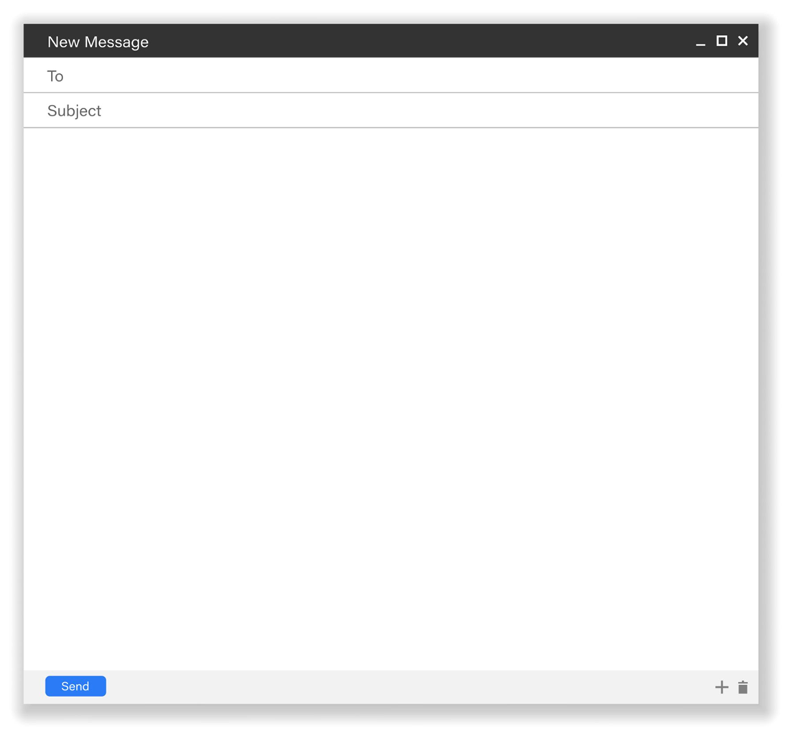

DRAFT ANNOUNCEMENT MESSAGING

Announcement! Growing our Competitive Advantage: Groopit Kick-Off Event on {Date}

Gathering and using competitive intelligence is our best chance at winning, keeping and growing our business. And do you know what gives us the best chance of getting that intel? **YOU! 🫵**

We’re just three weeks away from the **Growing our Competitive Advantage: {insert your company name here} + Groopit** event where we’ll dig into how we can easily use our collective insights to outsmart competitors. Don’t miss it!

In this hour-long event, we’ll share:

* Why competitive intelligence matters at {Company} <insert company logo as emoji>
* What Groopit is and how they help grow competitive advantage
* A short training: **everyone should come ready to share a bit of competitive intelligence using Groopit ✍️**
* A Town Hall-style Q&A so all of your questions are answered ❓
* Free lunch for every attendee! 🍕

Having the latest competitive intelligence is critical to {Company}’s success and **we can’t do it without you!**

We look forward to seeing you on {Date}!

Best,  
{{Sender}}

## **Invitation**

*Objective*: Extend formal invitations to attendees and facilitate RSVP.  
*Timing*: 2 weeks prior

Customize and send this calendar invitation to every potential participant, so you can request attendees RSVP. It should include event date, time, and location in the invitation. Ensure that invitations are sent 2-3 weeks in advance to allow for planning and logistics.

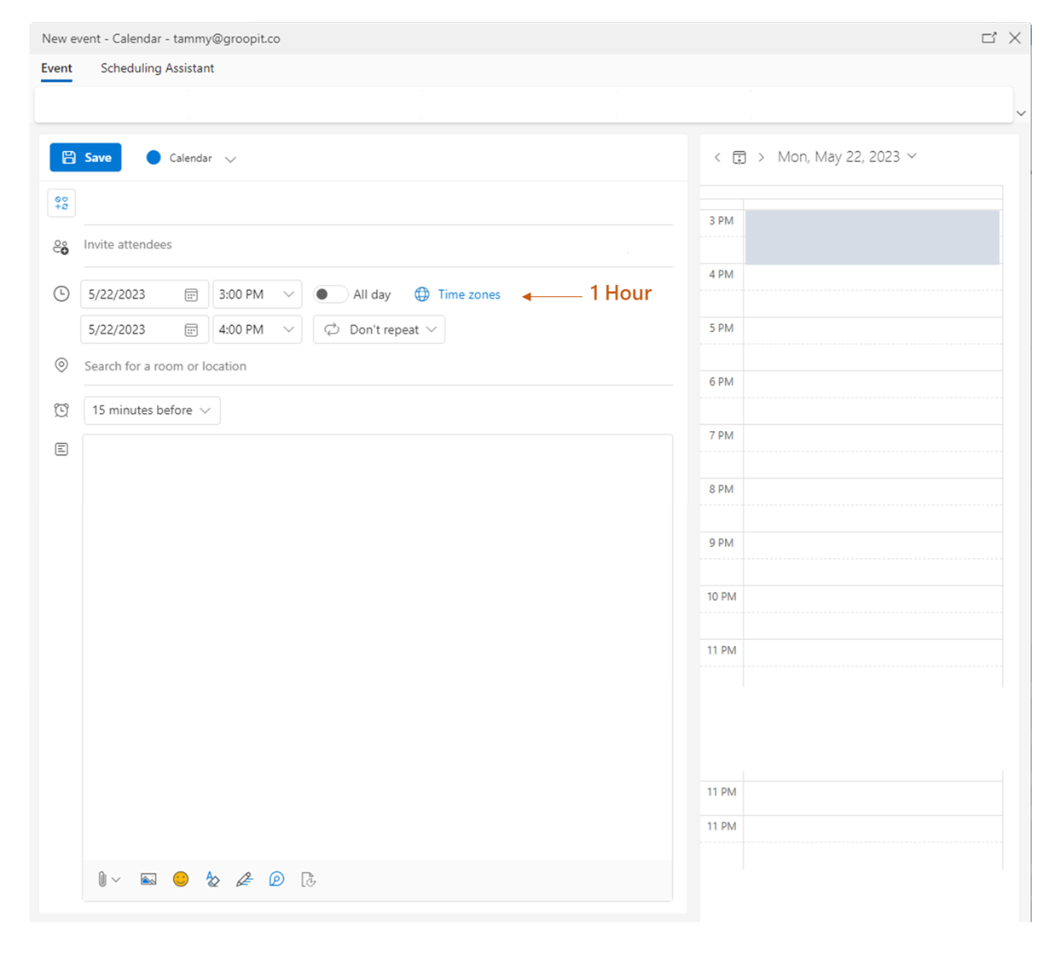

DRAFT INVITATION MESSAGING

Growing our Competitive Advantage: {Company} + Groopit Kick-Off Event

During this session, you'll learn what competitive intel to look for and how to share it - right in {Slack / Teams / Salesforce} - so that we can use our collective insights to outsmart competitors. Then, we'll show you how you can use the data to win, keep and grow more business.

Join us for a fun-filled hour that will include:

* Why competitive intelligence matters at {Company}
* What Groopit is and how they help grow competitive advantage
* A short training: **everyone should come ready to share a bit of competitive intelligence using Groopit**
* A Town Hall-style Q&A so all of your questions are answered
* Lunch for every attendee!

## **Giveaway Teaser**

*Objective*: Generate excitement and incentivize attendance.  
*Timing*: 1 week prior

Customize and send this teaser message highlighting a special treat for attendees, such as participants will receive a complimentary coffee or lunch during the event, or be entered into a drawing to win. This message is designed to emphasize that the treat is a token of appreciation for their attendance. It is also meant to build anticipation and encourage active participation.

DRAFT GIVEAWAY TEASER MESSAGING

Did someone say free lunch? And a giveaway? **😃**

We’re just one week away from the **Growing our Competitive Advantage: {insert your company name here} + Groopit** eventwhere we’ll dig into how we can easily use our collective insights to outsmart competitors. And you’ll dig into the lunch that will be provided during the event (yes, even if you’re remote)! 🍕🍕🍕

If lunch isn’t tempting enough, there’s also a giveaway that you won’t want to miss:

**{{Name of product giving away}}. 🎟️**

**{{Insert image of giveaway product}}**

Don’t miss the {Date} event, where we’ll share:

* Why competitive intelligence matters at {Company} <insert company logo as emoji>
* What Groopit is and how they help grow competitive advantage
* A short training: **everyone should come ready to share a bit of competitive intelligence using Groopit ✍️**
* A Town Hall-style Q&A so all of your questions are answered ❓

Having the latest competitive intelligence is critical to {Company}’s success and **we can’t do it without you! 🫵**

We look forward to seeing you at the event! 🎉

## **Leadership Teaser**

*Objective*: Highlight the importance of the event and encourage attendance.  
*Timing*: 3 days prior

Request a senior leader to send a message emphasizing the event’s significance and detailing its alignment with organizational goals and/or vision. Encourage the leader to highlight the positive impact of attendees’ participation, and inspire people to actively engage. This message is a customizable starting point to send to the leader as a suggestion.

DRAFT LEADERSHIP TEASER MESSAGING

Competitive Intelligence is Critical to Our Success

This week, you’ll participate in the **Growing our Competitive Advantage: {insert your company name here} + Groopit** event where you’ll learn how easy it is to share competitive intelligence right in {Slack / Teams / Salesforce}, through Groopit. In my opinion, this is one of the most important events you’ll attend this quarter.

Competitive Intelligence is critical to {Company}’s success and you are our greatest source of that intel. You’re having important discussions every day that give us insights into what our customers and prospects are seeing out in the market and where we are winning and losing. To stay competitive, we need you to share that intel in a way that is uniform and quantifiable. That’s what using Groopit can do for us.

Please come to this week’s event ready to learn, to share one piece of competitive intel through Groopit, and to ask questions. We want you to leave the event feeling confident using the tool and using its output to help win, keep and grow business.

Thanks in advance for your participation and for continuing to be a huge part of {Company}’s success.

## **Reminder**

*Objective*: Ensure attendees are well-prepared and excited for the event.  
*Timing*: 1 day prior

Customize and send this reminder message to all attendees the day before the event. This draft is designed to reinforce the importance of the event, encourage participants to come prepared to share competitive intelligence, and express gratitude for their commitment to participate.

DRAFT REMINDER MESSAGING

Get Ready for Tomorrow’s {Company} + Groopit Kick-Off Event

It’s all happening tomorrow! We’ve been preparing you over the last few weeks for tomorrow’s **Growing our Competitive Advantage: {insert your company name here} + Groopit** event we hope you’re ready and excited!

Here’s what you need to be ready:

1. **One piece of competitive intel** ready to share through Groopit during the training portion of the event.
2. **Any questions** you have about the why, how, or when of using Groopit, sharing competitive intel, or using that intel to win, keep and grow business.
3. **An appetite for the lunch** that will be provided

Having the latest competitive intelligence is critical to {Company}’s success and we can’t do it without you! 🫵

We look forward to seeing you at the event tomorrow!

Best,

{{Sender}}

# 

## **Promotional Graphics** The graphics provided for the kick-off event can be incorporated into various communication channels. Included in the playbook are banner and square format images, which can be used as is or customized on Canva. BANNER ASSETS Banner asset templates on Canva: [link](https://www.canva.com/design/DAFlD0KAazU/cjIGpwts_Rt6cC3Xj5odrg/view?utm_content=DAFlD0KAazU&utm_campaign=designshare&utm_medium=link&utm_source=publishsharelink&mode=preview).



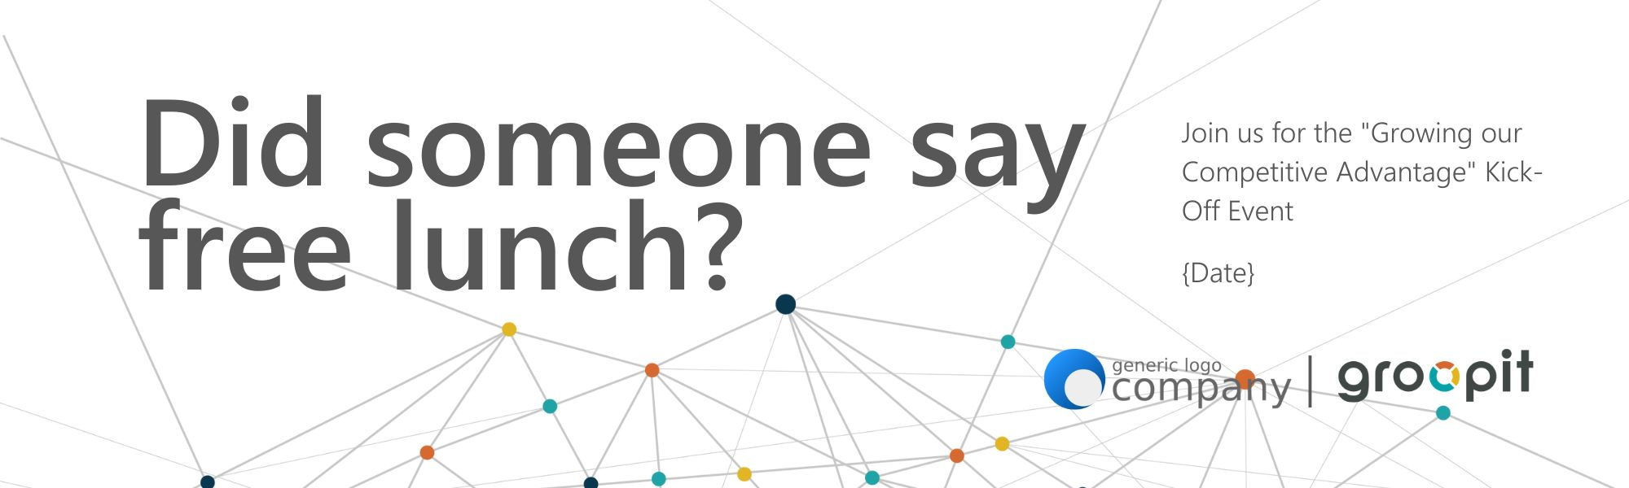



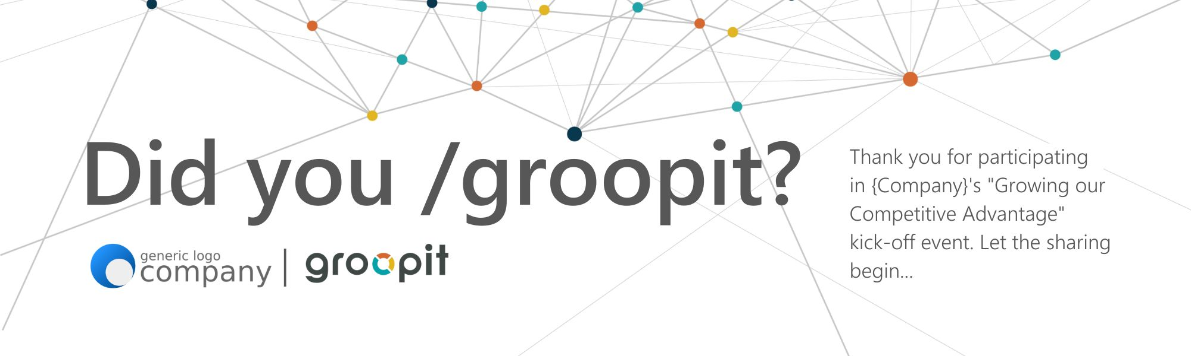

SQUARE Assets  
All square assets available for download and customization on Canva: [link](https://www.canva.com/design/DAFlPdX84kg/VM-Ka_61IYo-IUuK-GVb1Q/view?utm_content=DAFlPdX84kg&utm_campaign=designshare&utm_medium=link&utm_source=publishsharelink&mode=preview).

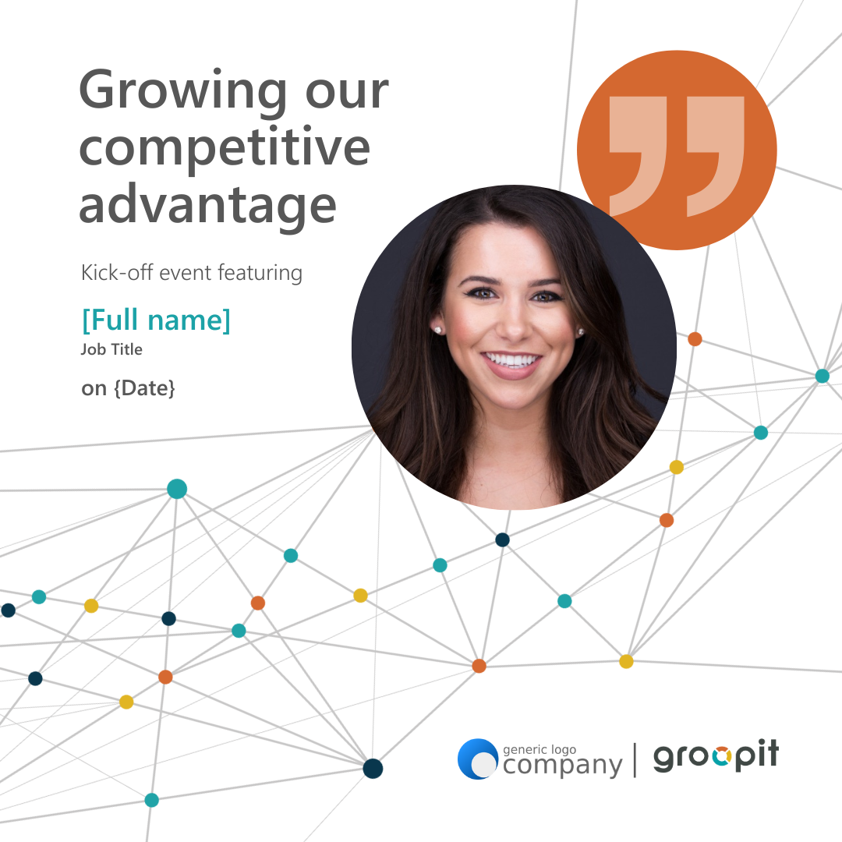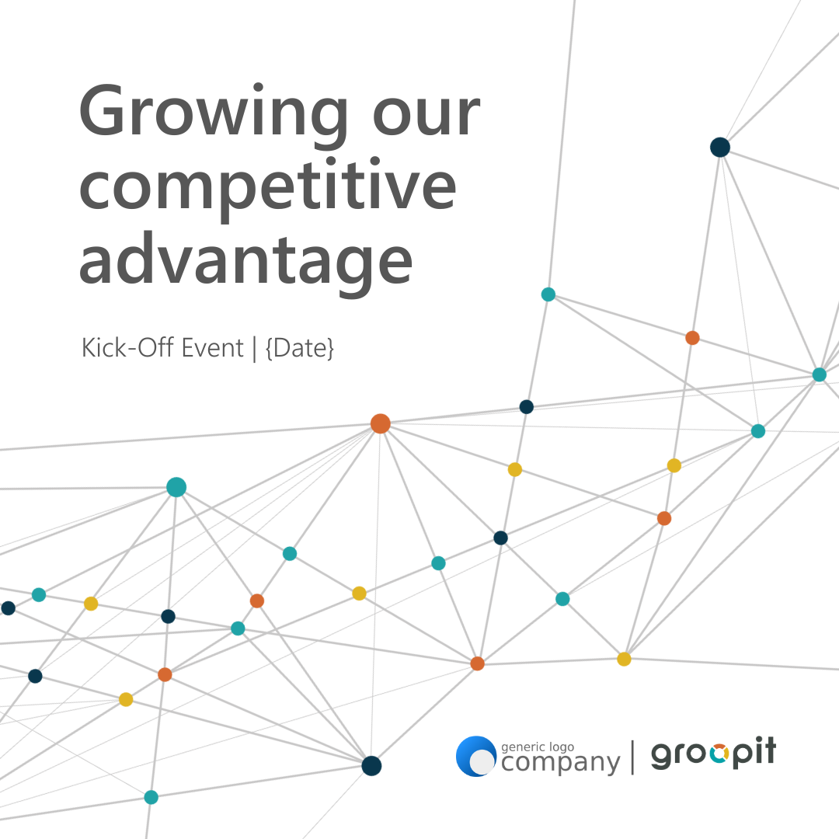

EMOJI Asset

Groopit logo for use as emoji: [link](https://groopit.co/wp-content/uploads/2022/05/Groopit-Tile.png).

## **Promotional Giveaway**

## *Objective*: Make the event fun with a giveaway for one or everyone.

## To make the kick-off event more enjoyable and incentivize participation, consider including a giveaway for attendees. Here are several ideas:

## **Breakfast for everyone**. Provide a coffee card or arrange for donuts to be delivered to each attendee. This will jump-start the event with a delightful and energizing treat.

## **Did someone say free lunch?** Offer DoorDash gift cards in advance or arrange pizza delivery to each participant. This will make the kick-off event feel like a special occasion.

## **Snacks! Snacks! Snacks!** Arrange for a cookie or snack plate to be delivered to each attendee. Having delicious snacks readily available will create a comfortable and engaging environment throughout the event.

## **Desk reminder:** Distribute [mousepads](https://www.vistaprint.com/promotional-products/technology/mouse-pads/photo-mouse-pad?PCXTVATINCLUSIVE=%3FcouponCode%3DNEW25&utm_id=2B06313488103203884862&coupon=&partner=google&ps_vtp=40219849%7C2150769379%7C%7Caud-1637287918276%3Akwd-25467830%7Cc%7C9033325%7C%7Cg&ps_vtp2=g%7Ccustomized+mouse+pad%7Ce%7C635956161003%7C%7C%7C%7C%7C&gclid=CjwKCAjw67ajBhAVEiwA2g_jELx5hIlMfBpWQeE7Z2yqDyzV4TvELaBbyYQuAS175m4Rvrv2w8J0BxoCfQ0QAvD_BwE) to each participant that will sit on their desks. This practical giveaway will serve as a constant reminder to actively contribute and foster a sharing culture within the organization.

## **Premium giveaway:** Organizing a drawing for a premium giveaway. Each time someone shares competitive intel, enter them to win. You’ll continue to build awareness by incorporating logos and the tagline "Did you groopit?".

PREMIUM GIVEAWAY EXAMPLES

A b[luetooth speaker](https://www.ipromo.com/ankerr-soundcore-mini-3-pro-bluetoothr-speaker), a p[ower bank](https://www.4imprint.com/product/147274-8?gfeed=1&mkid=1pla147274-8&ef_id=CjwKCAjw67ajBhAVEiwA2g_jEMlY2uZjIvgnCmexCCNRatYlrr1j-YYkcJvhQxhqG0enr9KoA4UAhRoC4HQQAvD_BwE:G:s&s_kwcid=AL!4167!3!610744960997!!!g!470036912814!!17757251254!138205798519&s_kwcid=AL!4167!3!610744960997!!!g!470036912814!&gclid=CjwKCAjw67ajBhAVEiwA2g_jEMlY2uZjIvgnCmexCCNRatYlrr1j-YYkcJvhQxhqG0enr9KoA4UAhRoC4HQQAvD_BwE), and a w[ireless charging pad](https://www.ipromo.com/5w-fabric-super-slim-wireless-charging-pad.html).

## 

# **Phase Two: Event**

## The event itself should lay the foundation for future success. It is designed to empower each employee and ignite the momentum necessary to excel in our competitive landscape. By the end, every attendee will understand the importance of competitive intelligence at your company, how Groopit can help grow competitive advantage,how to use Groopit, and they will have shared their first piece of competitive intelligence. **Speakers**

The 60-minute session features four speakers to contribute their expertise.   
  
A skilled **host** will welcome guests, introduce speakers, facilitate the questions & answer session, and guide the proceedings to ensure a smooth flow and engaging experience for all.



One of the speakers will be a respected **leader** from within our organization who will share insightful thoughts on the significance of competitive intelligence specifically within our company. 

Additionally, we suggest inviting a **guest** speaker to explain what Groopit is and how it can foster growth of competitive advantage.



Finally, a dedicated **trainer** will lead a session to equip employees with the skills to share and utilize competitive intelligence effectively.

Together, these four speakers will contribute to a dynamic and informative event, empowering attendees with valuable knowledge and tools to grow competitive advantage.

## **Presentation Slides**

The presentation for the kick-off event consists of ten slides, each designed to engage and inform the attendees. The **draft slides** can be customized and downloaded [here.](https://groopit.co/wp-content/uploads/2024/01/Groopit-Kick-Off-Event-Presentation-Template-v1.09.2024.pptx)

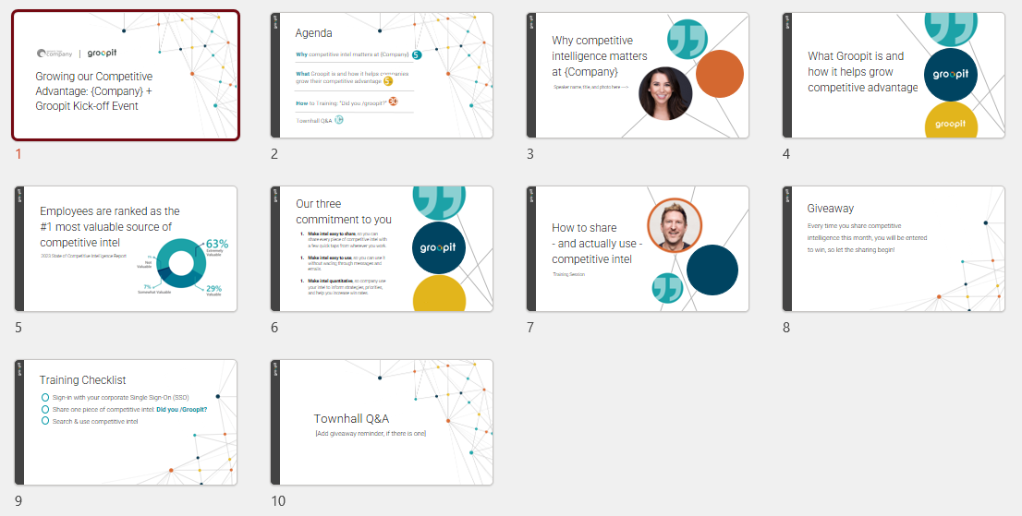

In the first slide, the host will warmly welcome participants to the event, setting the tone for an inspiring and collaborative experience.

The second slide presents the agenda, outlining the event’s flow and providing a clear roadmap for what to expect.

Next, there is a dedicated slide for each speaker, allowing them to share their insights and expertise.

Additionally, there is a slide specifically dedicated to the training checklist. This slide provides participants with a visual reference to ensure they are prepared to actively contribute and helps keep everyone on track and ensure that the training is effective and valuable.

After training is complete, there is a dedicated slide for Q&A. This slide provides a platform for participants to raise queries, seek clarification, and engage in meaningful discussions. It is an excellent opportunity for the host to foster collaboration and ensure that everyone's voices are heard.

## **Suggestions**

Before finalizing the agenda, talk through your company’s training culture. How do people learn best today? What works and what doesn’t in training sessions at your company? How does this format need to evolve to work best for your company and culture?

Schedule a practice session prior to the actual event, allowing the host and speakers to familiarize themselves with the agenda, flow, and technical aspects of the event. This provides an opportunity to address any potential issues, fine-tune presentations, and ensure a cohesive and engaging experience for all attendees. By investing time in a practice session, you can enhance the overall quality and effectiveness of the kick-off event, leaving a lasting impression on the audience and setting the stage for a successful event.



Set up polls ahead of time to gauge the attendees’ success with the training steps. Examples:  
  
**Question**: Now it’s your turn to SIGN-IN (it’s a one-time action):

* Sign-in Complete
* I’m unable to sign in

**Question:** Now it’s your turn to SHARE COMPETITIVE INTEL:

* I shared!
* I was not able to share.

Consider recording the kick-off event. This will allow you to create valuable resources that can be shared with new hires or employees who may have missed the live event. By recording and documenting the training session, you ensure that the knowledge and insights shared during the event can be accessed and utilized beyond the immediate scope of the kick-off event. This approach promotes continuous learning and enables you to leverage the training session as an educational resource for future onboarding and development purposes.



Enlist people to take on secondary roles to help session run smoothly. For example, you may want:

* One person to manage logistics: start the session, record it, monitor comments, start polls, and prompt breakout rooms.
* One person to make comments in the chat to reinforce key points the speaker has made (e.g., “Time to start sharing!” or “There’s a giveaway coming!”)
* Multiple people proactively share their thoughts during the Town Hall section of the agenda. For instance, a business leader to interject on why this is so important or how the data will be used, or an employee to speak to how this is an improvement over the old process.
* A participant from Groopit to deliver the Groopit promise section and offer support.

# **Phase Three: Nurture**

In this phase, we offer resources to help you consistently reinforce the importance of sharing while employees are developing a habit of doing so. In the initial month following the event, it is recommended to send a weekly email that builds upon the kick-off momentum. The nurturing messages are already written for you, so they're ready to customize and send. The messages are also available in [doc format](https://groopit.co/groopit-launch-communication-templates-2/) for easy copy and paste.

* Day after event: Send a thank you.
* Week one: Ask participants to invite a colleague.
* Week two: Remind participants about the giveaway.
* Week three: Share a tip & trick.
* Week three or four: Ask a leader to acknowledge and celebrate progress.
* Week four: Announce the giveaway winner.

Subsequently, we propose establishing a strong connection between sharing competitive intelligence and tangible business outcomes through a weekly highlights message (Groopit can help you automate this). Take a look at the weekly highlights template and the “Did you groopit?” templates you can use:

* Weekly highlights: Use the weekly highlights template provided.
* Did you groopit? Use the phrase to build a habit of sharing.

## 

## 

## **Day after event: Send a thank you**

*Objective*: Thank attendees for their participation and reinforce the messages from the event.

*Timing*: 1 day post kick-off event

Customize and send this message to thank event attendees for their participation.

DRAFT MESSAGING

Thanks for your participation – now, let’s start sharing!

Thank you so much for your participation in yesterday’s **Growing our Competitive Advantage: {insert your company name here} + Groopit** event! Your competitive insights will help drive competitive advantage and positive business results for {Company}. 💪

Going forward, any time you hear a piece of intel about a competitor, we hope you’ll head over to {Slack and type /groopit} / {Teams and type @groopit in the Search bar} / {Salesforce} to quickly and easily share it with the organization.

If you have any questions about the program or any trouble sharing, please don’t hesitate to reach out.

Over the course of the next few weeks, we’ll be sharing results and updates, so stay tuned to hear how your intel is driving success at {Company}.

Best,

{{Sender}}

## **Week five: Ask participants to invite a colleague**

*Objective*: Provide a status update on the program and ask participants to invite a colleague to join the Competitive Intelligence {Slack / Teams} Channel  
*Timing*: 1 week post kick-off event

Customize and send this message to provide an update on the program to-date and ask participants to invite a colleague to join the Competitive Intelligence {Slack / Teams} channel. This message is designed to drive continued engagement with the CI sharing program from current participants and extend it to new participants.

DRAFT MESSAGING

Did you groopit? Invite a colleague!

It’s been one week since we kicked off our Competitive Intelligence sharing program with Groopit and we’re already seeing great results! Keep up the great work and keep that intel coming! 🙌

If you’re already seeing the value of this program, **reach out to a colleague who you think would benefit from the knowledge we’re sharing**. The more people who are contributing - and using - the competitive intel shared, the stronger our competitive advantage will be! 💪

Here’s how you can easily add someone to the {Slack / Teams} channel. {[Slack instructions](https://slack.com/help/articles/201980108-Add-people-to-a-channel)} / {[Teams Instructions](https://support.microsoft.com/en-us/office/share-a-channel-with-people-in-teams-5f60de2d-0080-4e55-b26f-33a9dafa120e)}

Thank you again for your continued contributions to our competitive intelligence program - we couldn’t do it without you!

Best,

{{Sender}}

## 

## **Week six: Remind participants about the giveaway**

*Objective*: Provide a status update on the program and giveaway reminder

*Timing*: 2 weeks post kick-off event

Customize and send this message to provide a program update and remind participants about the forthcoming giveaway. This message is designed to drive continued engagement with the CI sharing program.

DRAFT MESSAGING

Did you groopit? Giveaway reminder!

It’s been two weeks since we kicked off our Competitive Intelligence sharing program with Groopit and we are very pleased with the results to-date! Keep up the great work and keep that intel coming! 🙌

And don’t forget, **every time you share competitive intel through Groopit, from now through {Date}, you’ll be entered into a drawing to win a {{Name of product giving away}}. 🎟️🎟️🎟️**

**{{Insert image of giveaway product}}**

Thanks again for your continued contributions to our competitive intelligence program - we couldn’t do it without you!

Best,

{{Sender}}

## **Week seven: Share a tip & trick**

*Objective*: Forward the Groopit Tips & Tricks email

*Timing*: 3 weeks post kick-off event

*Tip:* Groopit publishes shareable tips and tricks every month to help employees get more out of the collective intelligence everyone has shared. When you receivea tip & trick from Groopit that you think can benefit employees, forward it and emphasize why you think it’s worth reading. You might just add, “*This Tip & Trick may help you win more business because you can search for insights about specific competitors when you’re competing to win a deal.”*

DRAFT MESSAGING

Fwd: Groopit Tips & Tricks

This tip & trick may help you win more business because you can search for insights about specific competitors when you’re competing to win a deal.

From: Groopit

Sent: Thursday, July 3, 2023 10:00 AM

Subject: Groopit Tips & Tricks

Did you know you can filter and view insights by competitors in Groopit?

Follow these steps:

* Navigate to the Groopit dashboard at https://app.groopit.com.
* Click the “Data” icon on the left
* In the search bar, type the name of the competitor you need to view intel on

You can also use the dropdown next to the search field to filter what type of intel you are looking for.

Thanks,

Team Groopit

## **Week seven or eight: Ask a leader to acknowledge and celebrate progress**

*Objective*: Acknowledge and celebrate the continued engagement  
*Timing*: 3 or 4 weeks post kick-off event

Request that a senior leader send a message that acknowledges and celebrates the intel that is being shared through Groopit. Encourage the leader to highlight the positive impact of participation and inspire people to continue to actively engage. This message is a starting point that you can customize and send to the leader as a suggestion.

DRAFT MESSAGING

Did you groopit? Thank you from {Senior Leader Name}

I want to extend a personal thank you for your continued engagement with our CI sharing program and for the great intel you’ve already contributed through Groopit.

Competitive Intelligence is critical to {Company}’s success and the insights you’ve contributed are having a direct, positive impact on our ability to be competitive.

Please continue to share what you are seeing and hearing in your conversations so we have a clear view into where we are winning and losing and can be nimble in our response.

In a few days, {{Name of program leader}} will share the winner of the {{name of giveaway}}. Our commitment to sharing and learning from competitive intelligence is critical and we can’t do it without you.

Best,

{{Sender}}

## **Week eight: Announce the giveaway winner**

*Objective*: Announce giveaway winner

*Timing*: 1 Day after giveaway entry period has ended

Draw and announce the winner of the giveaway promotion.

DRAFT MESSAGING

Announcing our Did you groopit? Giveaway winner! 🎉

It’s been over a month since we kicked off the “Growing our Competitive Advantage with Groopit” program and the results have been exciting! As promised, each time you submitted a piece of intel through Groopit, your name was added to the drawing to win the **{{Name of product giving away}}.**  We’re happy to announce that the winner is... 🥁

**🌟 NAME OF WINNER 🌟**

Congratulations, {{Name}} - we hope you enjoy it!

Thanks again for your continued contributions to our competitive intelligence program - we couldn’t do it without you!

Best,

{{Sender}}

# 

## **Weekly Highlights Template**

*Objective*: Summarize sharing, acknowledge contributors, highlight a key insight, provide a link to access all insights, and incorporate a visual element.

Establishing a strong connection between sharing competitive intelligence and tangible business outcomes is of utmost importance. This connection enables everyone to recognize the significant role their contributions play in building a sustainable competitive advantage for the company. The weekly highlights template will help you acknowledge and emphasize sharing and its direct impact on business results, generate fuel that will power the company's engine, and create a competitive edge year after year.

*Timing*: Once per week. For example, highlight the previous week on Mondays.

*Tip:* Ask your Groopit customer success rep to help automate this process.

*Tip:* You can also use the weekly highlight as an opportunity to celebrate wins, achievements, and progress related to competitive intel shared. By sharing stories of achievement, you foster a culture of recognition and encourage continued sharing of valuable intelligence.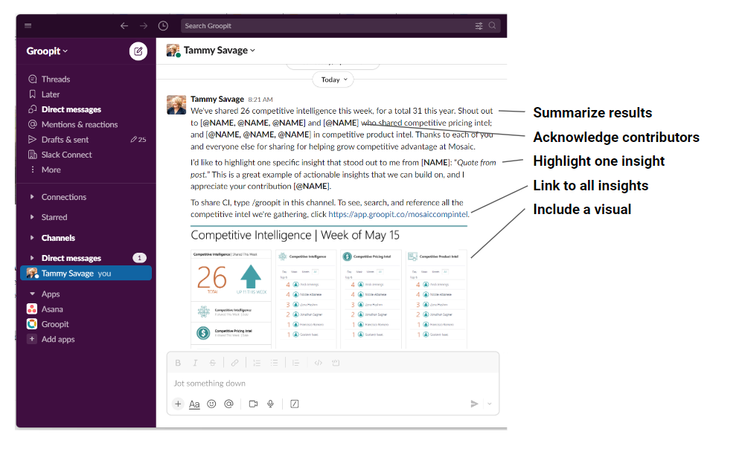

*Example post in Slack:*

## 

## 

## 

## 

## 

## 

## 

*Example text:*

We’ve shared 26 competitive insights this week, a total of 159 this year. Shout out to @name, @name, @name, and @name who shared competitive pricing intel for the first time. And @name, @name, and @name who shared competitive product intel. Every share gets us one step closer to growing our competitive advantage.

I’d like to highlight one specific insight that stood out to me from @name. [Insert quote or snippet]. This is a great example of [insert reason], an actionable insight that we can build on.  
  
To share CI, {type /groopit in this Slack channel / type @groopit in the Teams search bar / use Groopit in Salesforce}. To see, search, and reference all competitive intel we’re gathering, click [insert your custom link found in the about section of your Groopit].

## 

## 

## 

## **Did you groopit? to build a sharing habit**

Aim to build a habit of sharing competitive intelligence. One approach that works well is to incorporate the phrase “**Did you groopit?**” into your corporate vernacular. Whenever an employee is talking about a competitor and has a valuable insight, someone on the team should say, “Did you groopit?” It’s a way to say, “That insight is valuable and needs to be shared so everyone can use it.”  
  
This strategy can also be implemented in Slack or Teams. 

{SLACK INSTRUCTIONS}

Whenever someone is talking about a competitor but hasn’t captured the data, type “Did you /groopit?” to activate this [animated gif](https://groopit.co/wp-content/uploads/2023/05/Groopit-GIF-Did-you-groopit.gif). It will serve as a fun reminder and help build the sharing habit across the organization.   
  
SET-UP INSTRUCTIONS  
  
Use the Slackbot custom responses feature and activate this [gif](https://groopit.co/wp-content/uploads/2023/05/Groopit-GIF-Did-you-groopit.gif) every time someone types “Did you /groopit?” on Slack.

1. In the top left in Slack, click the down arrow next to the name of your Slack group and then select “Customize {Slack group name}”.
2. If you see a tab that says “Slackbot”, then you have access to add custom responses. If you do not, you may need your administrator to give you access or to set this up for you.
3. In the Slackbot tab, click “+Add New Response”
4. In the box below, “When someone says,” type: did you groopit, did you /groopit, did you groopit?, did you /groopit?
5. In the box below “Slackbot responds,'' type the URL of the “Did you /groopit?” gif: <<Lisa to add URL when we have gif created and hosted>>
6. Click Save.

{TEAMS INSTRUCTIONS}

Whenever someone is talking about a competitor but hasn’t captured the data, send this [animated gif](https://groopit.co/wp-content/uploads/2023/05/Groopit-GIF-Did-you-groopit.gif) in the chat. It will serve as a fun reminder and help build the sharing habit across the organization.

INSTRUCTIONS:

1. Download the gif and save the file somewhere that is easily accessible to you, like your desktop.
2. When you want to send it in teams, simply select and copy the file, then paste it into the Teams chat and press send.

# **Checklist**

We have consolidated all the suggestions into a comprehensive checklist that can be utilized either in spreadsheet format ([link](https://groopit.co/wp-content/uploads/2023/06/Groopit-Kick-Off-Task-List.xlsx)) or integrated into your preferred project management tool.

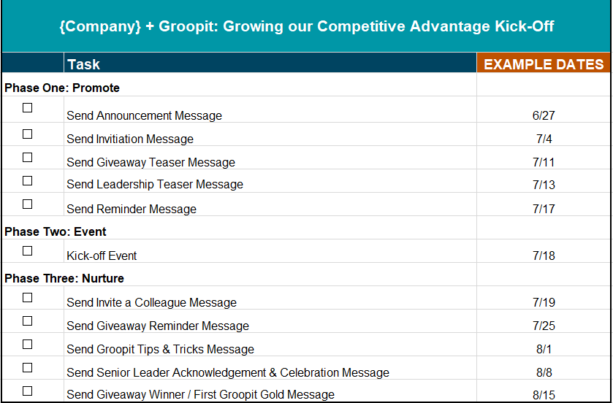

# **Resources**

Throughout this playbook, you’ll find links to multiple resources with instructions on how to use them at each stage of the kick-off process. We’ve compiled a list of all resources here, so you are able to easily access them as needed.

* [Customizable task list](https://groopit.co/wp-content/uploads/2023/06/Groopit-Kick-Off-Task-List.xlsx)
* [Message templates in document format for easy copy/paste](https://groopit.co/groopit-launch-communication-templates-2/)
* [Instructions for adding {Company} and Groopit logos as emojis in Slack](https://slack.com/help/articles/206870177-Add-custom-emoji-and-aliases-to-your-workspace)
  + [Groopit logo to use as emoji](https://groopit.co/wp-content/uploads/2019/08/groopitfavicon.png)
* [Promotional graphics - banner templates](https://www.canva.com/design/DAFlD0KAazU/cjIGpwts_Rt6cC3Xj5odrg/view?utm_content=DAFlD0KAazU&utm_campaign=designshare&utm_medium=link&utm_source=publishsharelink&mode=preview)
* [Promotional graphics - square templates](https://www.canva.com/design/DAFlPdX84kg/VM-Ka_61IYo-IUuK-GVb1Q/view?utm_content=DAFlPdX84kg&utm_campaign=designshare&utm_medium=link&utm_source=publishsharelink&mode=preview)
* [Kick-off event draft presentation slides](https://groopit.co/wp-content/uploads/2024/01/Groopit-Kick-Off-Event-Presentation-Template-v1.09.2024.pptx)
* [Did you groopit? animated gif template](https://www.canva.com/design/DAFlD0i-_cM/tjGMJMzpgBvada4xyD_OZA/edit?utm_content=DAFlD0i-_cM&utm_campaign=designshare&utm_medium=link2&utm_source=sharebutton)

# **Conclusion**

Let this playbook be the catalyst that ignites momentum and establishes a strong foundation for your competitive intelligence initiative. It equips kick-off coordinators with the knowledge, tools, and assets necessary to host a successful event and foster a culture of continuous intelligence sharing. From the initial promotion to the delivery of engaging presentations, and the nurturing of ongoing engagement, we eagerly anticipate hearing about your innovative ideas and how you further build upon this step-by-step guide. We encourage you to personalize the messages and strategies to align them with your company's unique vision, goals, and culture.

The Groopit team is honored to be a part of your journey and is fully dedicated to supporting your success. Should you have any questions, comments, or suggestions, please don't hesitate to reach out to your dedicated customer success representative or contact us at **hello@groopit.co**.

Thank you for your commitment and for entrusting us with this important initiative. We are excited to witness the growth and impact that your kick-off event and ongoing efforts will bring.